
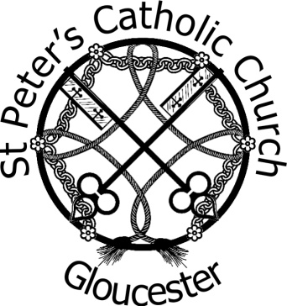
St Peter’s Catholic Church
London Road, Gloucester GL1 3EX
Tel: 01452 523603
Email: confirmation.gloucester.stpeter@Cliftondiocese.com
Parish website: www.stpetersgloucester.org.uk
Diocesan website: www.cliftondiocese.com
Diocese of Clifton Registered Charity No. 1170168

APPLICATION FORM FOR THE SACRAMENT OF CONFIRMATION 2026

Applicants must be baptised Catholic and in Year 9 or above from September 2025

Confirmation is something a Candidate must desire and therefore should apply to be prepared for the Sacrament themselves and fully engage in the programme. As part of this process the Candidate must provide a brief statement/reflection as to why they want to be Confirmed. Space for this statement/reflection is on page 2 of this Application.

All Forms to be completed by the Applicant and submitted by email to: confirmation.gloucester.stpeter@cliftondiocese.com
Submission Deadline: 1st December 2025

Applicant’s Full Name:

Address:

Postcode:

Date of Birth:

School:

Class year in Sept 2025:

Church usually attended:

Parent/Guardian/Carer Details:

Name: Tel/Mob:

Email:
Applicant’s Baptism Details
Parish of Baptism:
Date of Baptism:
If you do not have a copy of your Baptism Certificate, please contact the Parish where you were Baptised for a copy. Certificates need to be submitted with this form.

Applicant’s Reflection/Statement:
Speak from your heart, no one will judge you. This is not going to be marked or critiqued in any way. It is simply you asking to be Confirmed and showing your desire and commitment to take responsibility for your Faith:

Please email this form to confirmation.gloucester.stpeter@cliftondiocese.com or it can be printed and sent to: St Peter’s Presbytery, 9 London Road, Gloucester GL1 3EX
Submission Deadline: 1st December 2025.
Information provided on this form, together with all other personal data held about these individuals by the Parish and the Clifton Diocese, is processed in accordance with the Diocese's Privacy Notice; which is available at https://cliftondiocese.com/privacy-notice or from the Parish Office.

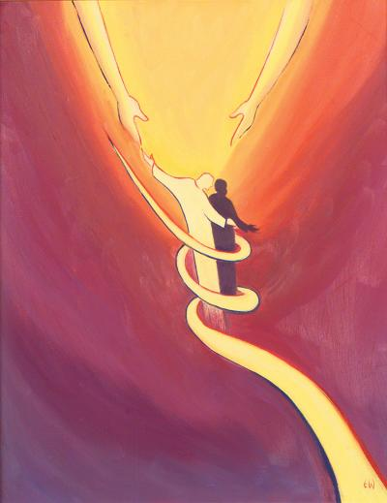

St Peter’s Confirmation Programme 2026

Unless otherwise stated, all sessions take place in the parish hall after the 5:30 Mass
7/12/25 | Welcome to St Peter’s Confirmation Programme | Introduction by Father Gary  6.45pm to 7.15pm
11/1/26 | 5.30 Mass  Session 1 - #279 to #290 | Commitment to Programme  Search for Happiness
18/1/26 | Session 2 - #1 to #6; #352 to #357 | The Existence of God
25/1/26 | Session 3 - #86 to #112 | Who is Jesus
1/2/26 | Session 4 - #469 to #489 | The Power of Prayer
8/2/26 | Session 5 - #291 to #298; #343 to #351 | Finding True Freedom
15/2/26 | No Session | Half Term
22/2/26 | No Session | Half Term
1/3/26 | Session 6 - #166 to #192; #193 to #207; #310 to #311 | The Liturgy. The Sacraments of Baptism and Confirmation
8/3/26 | Stations of the Cross (in Church) | 3rd Sunday of Lent
15/3/26 | No Session | Mothering Sunday
21/3/26 | Retreat Day | Prinknash Abbey
29/3/26 | No Session | Palm Sunday
5/4/26 | No Session | Easter Sunday
12/4/26 | No Session | Divine Mercy
19/4/26 | Session 7 #312 to #192; #224 to #247 | Forgiveness, Healing and Mission
26/4/26 | Session 8 - #145; #248 to #259; #260 to #271; #400 to #425 | The Christian Vocations
3/5/26 | No Session | Bank Holiday Weekend
10/5/26 | Session 9 - #208 to #223 | The Holy Eucharist
17/5/26 | Rehearsal (in Church)
21/5/26 | Confirmation

